PROJECT TITLE
Machine Learning-Based Sales Forecasting Using the Marketing and Product Performance Dataset
- INTRODUCTION
Sales forecasting plays an important role in business decision-making, inventory management, marketing planning, and revenue optimization. Accurate forecasting enables organizations to understand future demand patterns and allocate resources effectively. Machine learning techniques provide powerful tools for identifying complex relationships within large datasets and generating accurate predictions.
This project develops and evaluates several supervised machine learning models for forecasting sales using the Marketing and Product Performance Dataset obtained from Kaggle. Different machine learning algorithms, preprocessing techniques, feature importance methods, and robustness analyses are investigated to identify the most suitable forecasting model.
- DATASET INFORMATION
Dataset Name:
Marketing and Product Performance Dataset
Source:
https://www.kaggle.com/datasets/algozee/multi-source-data-for-e-commerce-sales-prediction
Number of Records:
100,000 rows
Number of Features:
18 columns
Application Domain:
E-commerce Sales Forecasting
Target Variable:
sales_amount_gbp
Task Type:
Regression

- PROBLEM STATEMENT
Businesses require accurate forecasting models to estimate future sales and support strategic planning. Traditional forecasting methods often fail to capture nonlinear relationships between economic indicators, product characteristics, customer behavior, and sales performance.
The objective of this project is to develop and evaluate supervised machine learning models capable of accurately predicting sales amounts using historical transaction, product, and economic data.
- RESEARCH QUESTIONS
RQ1:
How effectively can baseline supervised learning models predict sales_amount_gbp using the Marketing and Product Performance Dataset?
RQ2:
Which machine learning model achieves the best predictive performance for sales forecasting?
RQ3:
How do different preprocessing strategies affect machine learning model performance?
RQ4:
Which features contribute most significantly to sales prediction?
RQ5:
How sensitive are model rankings to different evaluation metrics?
RQ6:
How robust is the selected machine learning model under different validation and data quality conditions?
RQ7:
Which model provides the best balance between predictive performance, robustness, interpretability, and deployment suitability?

- PROPOSED METHODOLOGY
Step 1:
Dataset collection from Kaggle.
Step 2:
Data preprocessing including:
• Missing value handling
• Feature encoding
• Feature scaling
• Data cleaning
Step 3:
Exploratory data analysis.
Step 4:
Feature-target separation.
Step 5:
Train-test split using 80% training data and 20% testing data.
Step 6:
Model development and evaluation.
Step 7:
Feature importance analysis.
Step 8:
Robustness testing.
Step 9:
Final model recommendation.
- MACHINE LEARNING MODELS
The following supervised learning models are evaluated:
• Linear Regression
• Decision Tree Regressor
• K-Nearest Neighbors (KNN)
• Random Forest Regressor
• Gradient Boosting Regressor
• XGBoost Regressor

- EVALUATION METRICS
The project uses regression evaluation metrics:
• Mean Absolute Error (MAE)
• Root Mean Squared Error (RMSE)
• Coefficient of Determination (R²)

- EXPECTED TABLES
Table 1:
Baseline Model Performance
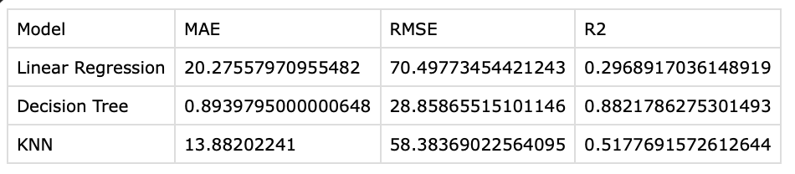
Table 2:
Model Comparison Results
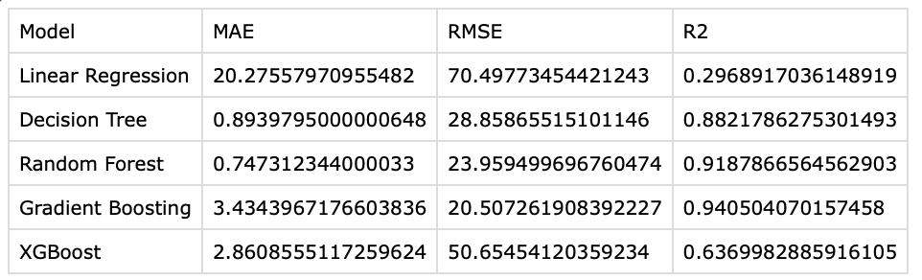
Table 3:
Impact of Preprocessing Techniques
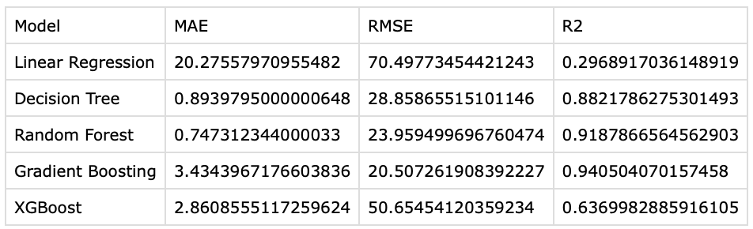

Table 4:
Feature Importance Rankings
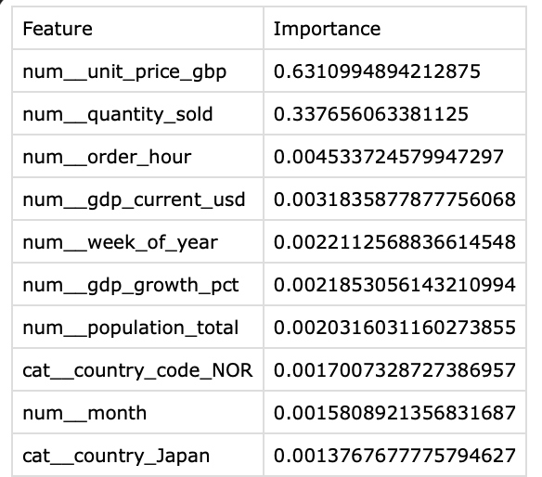
Table 5:
Model Ranking under Different Metrics
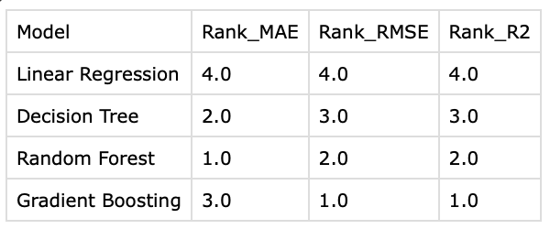
Table 6:
Robustness Analysis Results
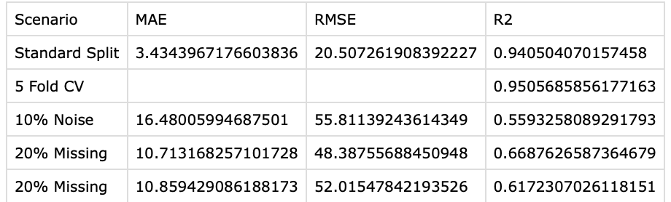
Table 7:
Final Decision Matrix and Recommendation
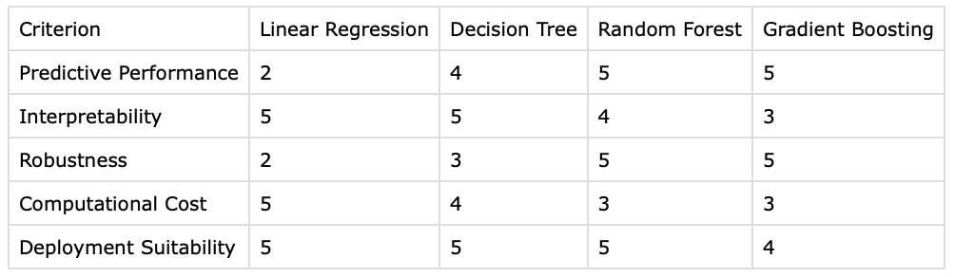

- EXPECTED FIGURES
Figure 1:
Baseline Performance Comparison
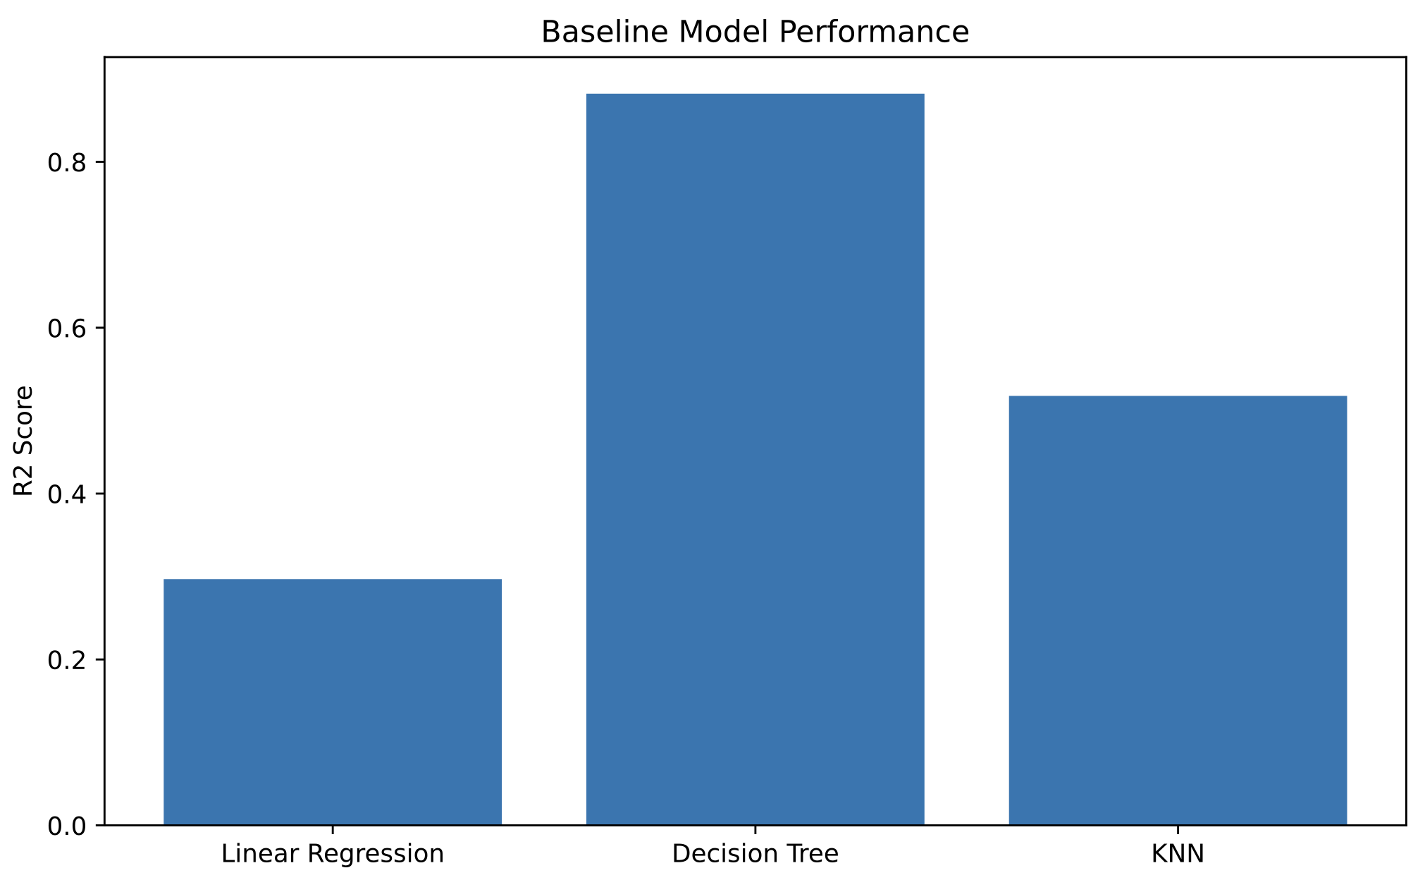

Figure 2:
Model Comparison Analysis
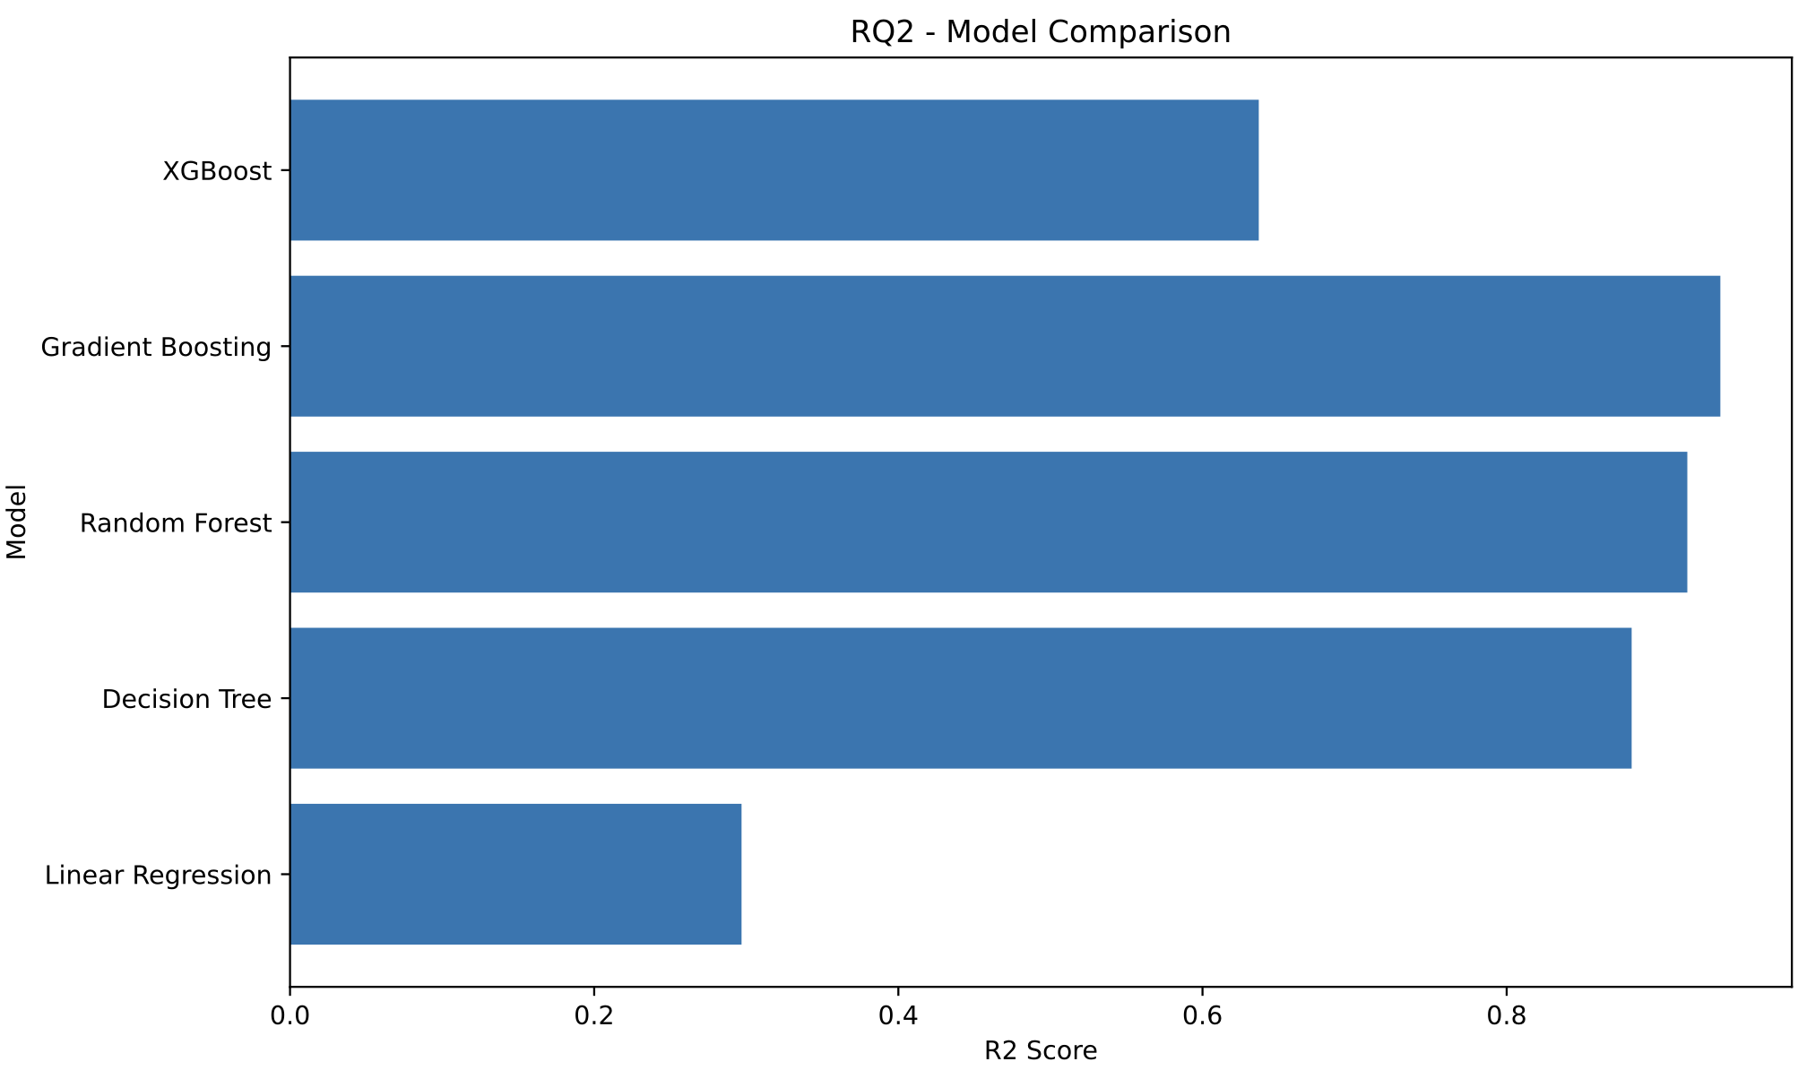

Figure 3:
Impact of Preprocessing on Model Performance
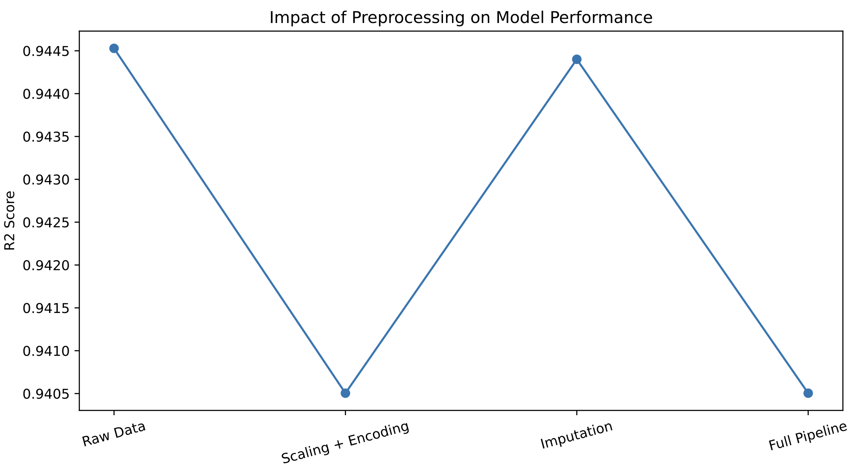
Figure 4:
Feature Importance Analysis
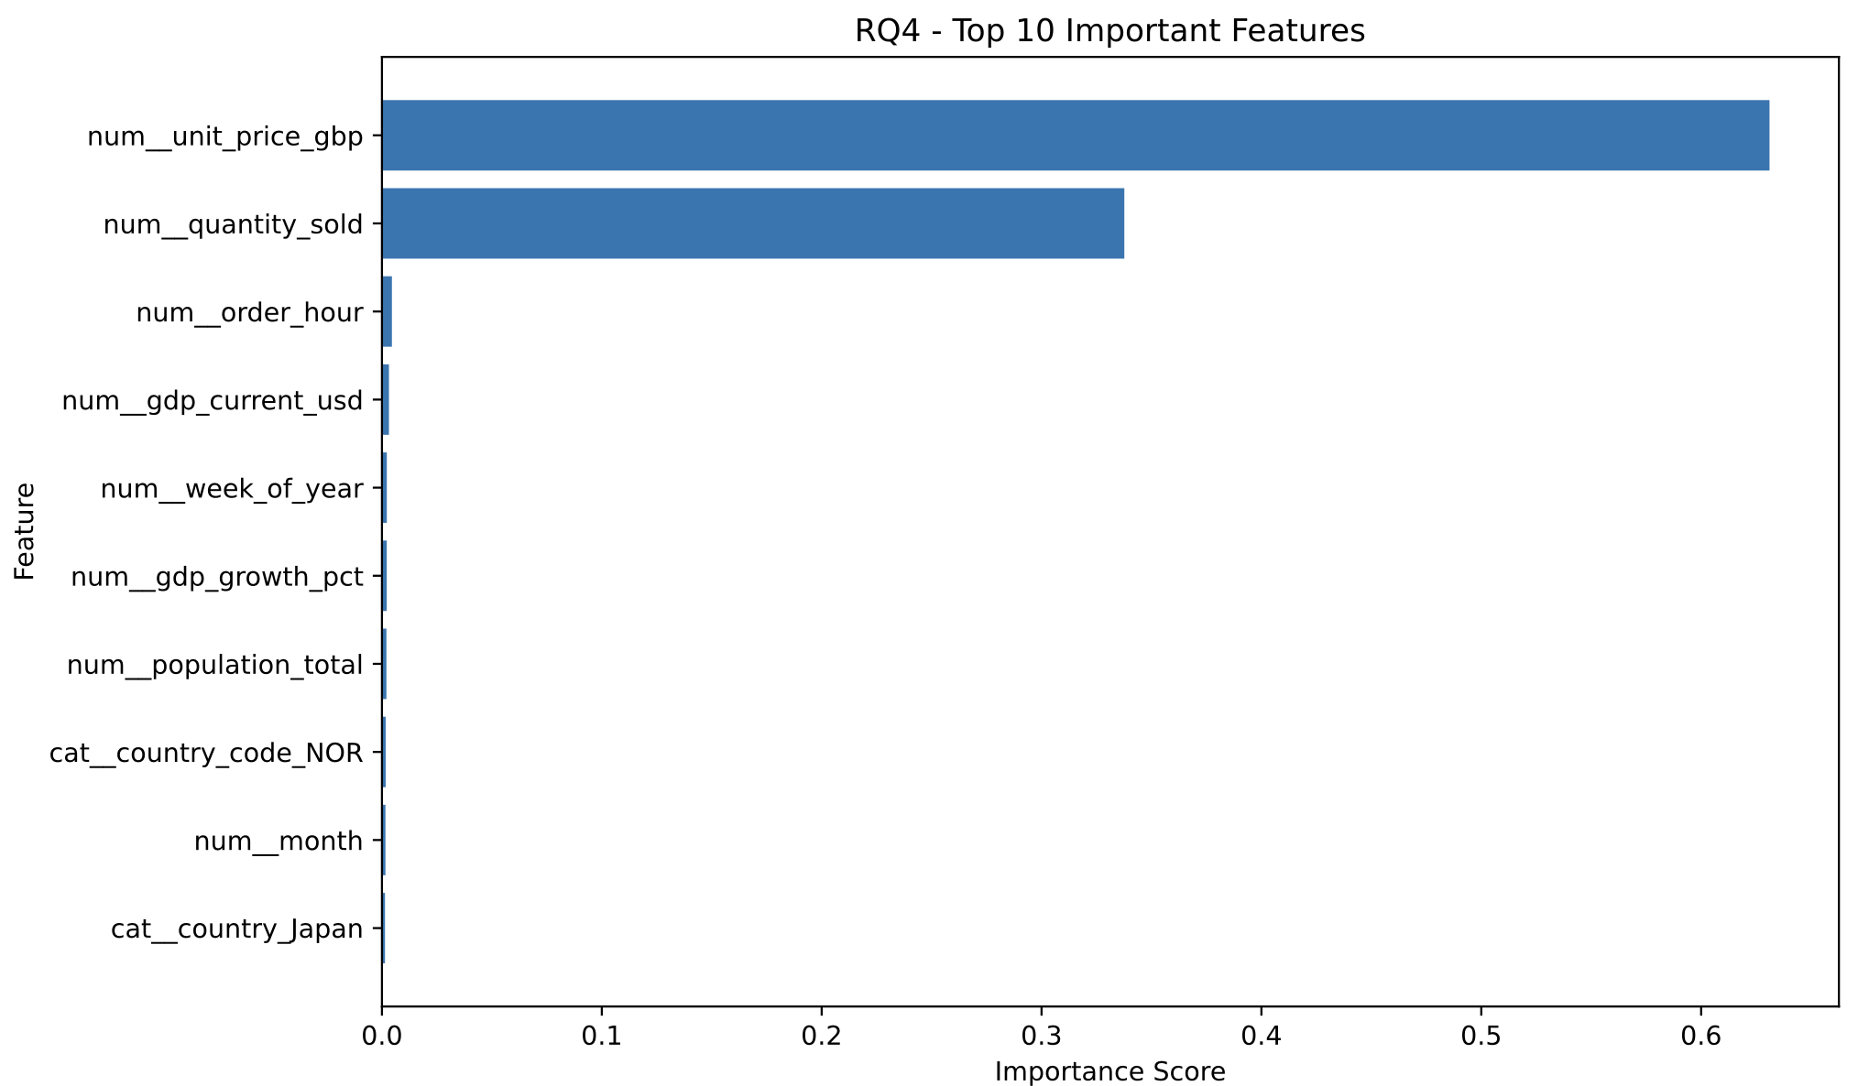
Figure 5:
Model Ranking Across Evaluation Metrics
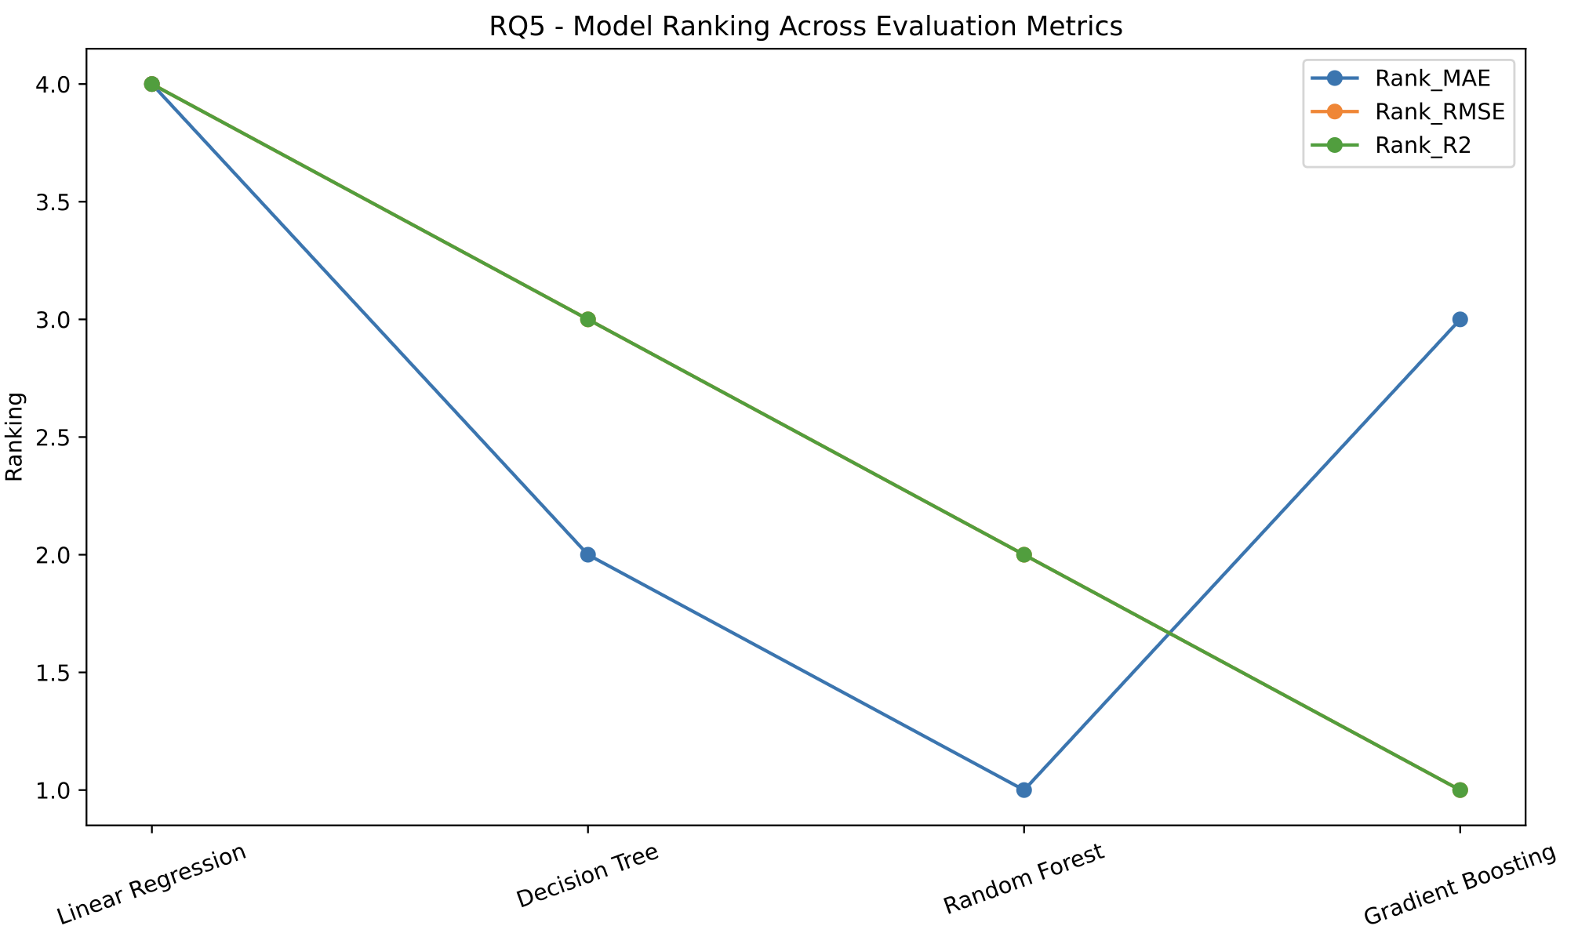
Figure 6:
Robustness Analysis
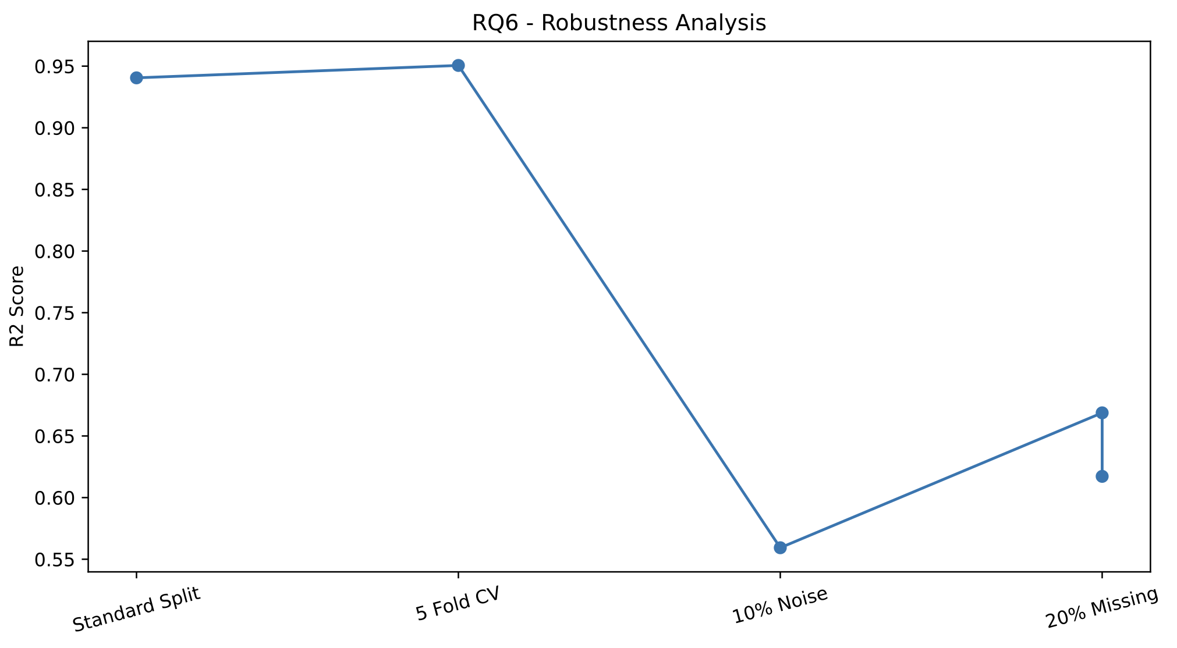
Figure 7:
Final Model Recommendation
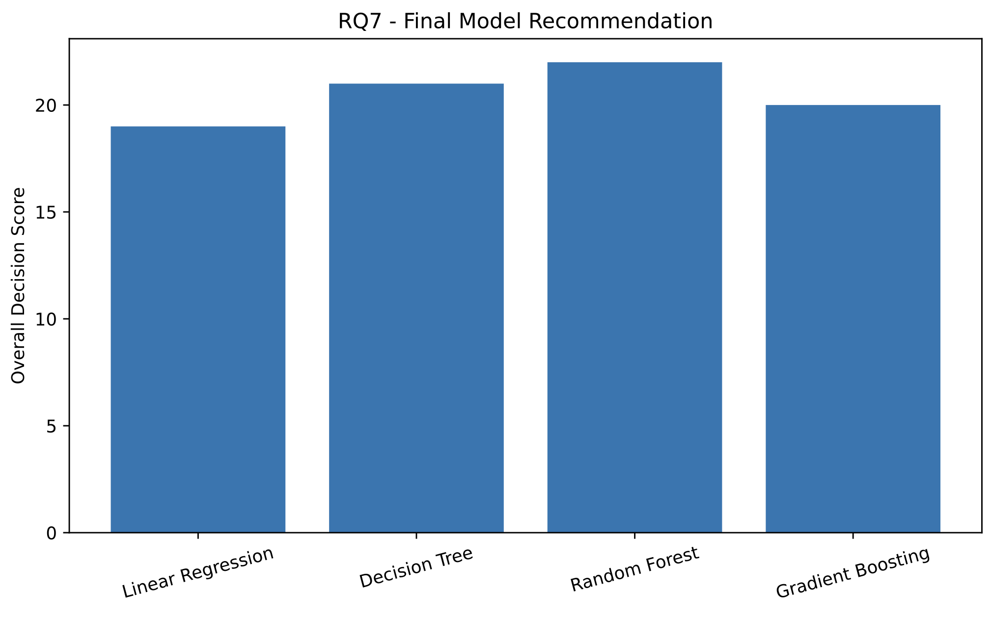

- EXPECTED OUTCOMES
The study is expected to demonstrate that machine learning techniques can effectively forecast sales using marketing and product performance data. Ensemble-based methods such as Random Forest and Gradient Boosting are expected to outperform simpler baseline models. Feature importance analysis is expected to identify the most influential factors affecting sales. The final recommended model is expected to provide strong predictive accuracy, robustness, and practical deployment suitability.

- TOOLS AND TECHNOLOGIES
Programming Language:
Python
Development Environment:
Google Colab
Libraries:
• Pandas
• NumPy
• Scikit-Learn
• Matplotlib
• XGBoost
Version Control:
GitHub
Dataset Platform:
Kaggle
- CONCLUSION
This project proposes a comprehensive supervised learning framework for sales forecasting using the Marketing and Product Performance Dataset. Multiple machine learning algorithms, preprocessing strategies, and evaluation techniques are employed to identify the most effective forecasting solution. The final outcome will assist businesses in making data-driven decisions and improving operational performance through accurate sales prediction.

